**Lab 1 - SQL**

**Each problem is worth one point. This lab is worth a total of 20 points.**

**Place all answers into ONE .sql file. Upload to Canvas. Only one .sql file will be accepted.**

1. **Can the SELECT statement be used to alter data within a table? Explain your answer.**

**\*\*\*\* The following questions use tables from the Student table space \*\*\*\***

1. **Using the DESCRIBE table command, create the following result table using the student**

**employee table.**

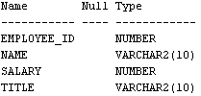

**3. Display all rows and columns within the employee table.**

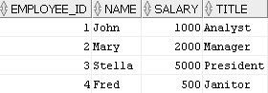

**4. List the students by last name followed by first name. Use ROWNUM to limit to 20 rows. Use the student table.**

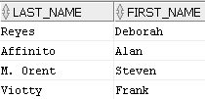

**5. List the students by last name followed by first name. Assign the label “FN” for a**

**student’s first name and “LN” for a student’s last name. Use ROWNUM to limit to 20 rows. Use the student table.**

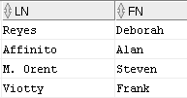

**6. List all unique zip codes. Use ROWNUM to limit to 20 rows. Use the student table.**



**7. List all students last names without any capitalization. Use ROWNUM to limit to 20 rows. Use the student table.**

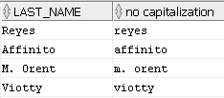

**8. List the first three characters of all course descriptions. Use the course table.**

**Partial result table (total of 30 rows)**

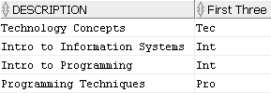

**9. List the last three characters of all course descriptions. Use the course table.**

**Partial result table (total of 30 rows)**

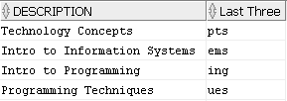

**10. List the unique employers of the students and place them in ascending alphabetic order**

**(use the Order By clause). Use ROWNUM to limit to 20 rows. Use the student table.**

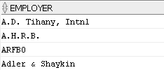

**11. List the courses by description followed by course_no. Use the course table.**

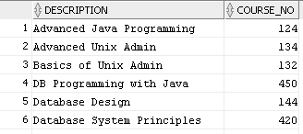

**12. Use the statement above and add Course Description and Course # as alias columns.**

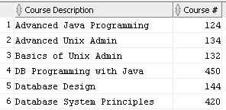

**13. List all distinct prerequisites for the classes. (17 rows)**

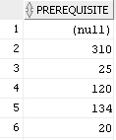

**\*\*\*\* The following questions use the dual table \*\*\*\***

**14. Explain what the dual table is used for.**

**15. Display all columns and rows of the Dual table.**



**16. Display the sum of 2 + 4 using the DUAL table.**



**17. Display 5 times 3, 5 minus 3, and 5 divided by 3. Use the Dual table.**



**18. Display 5 divided by 3 as a rounded value as per the following result table. Use the Dual**

**table.**



**19. List the current date using the Dual table.**

**Of course, you need to display today’s current date.**



**20. List yesterday’s date using the Dual table.**

**Yesterday’s date based on today’s current date.**

